Software Requirements Specification

Version 0.2 approved

Introduction

Purpose
This software is generally a discussion portal which will be an integration to the NIIT UNIVERSITY’s present Moodle Web page. It is being developed to make discussions more open and information passing easier. Users login with their username and password and gets access to this portal.

Document Conventions
Headings and sub headings are written in Bold size to highlight and naming and numbering has been done to categorize the sub-sections under the main Heading. The format used in this document is MLA.

Intended Audience and Reading Suggestions
The audience for our product are the students, faculty and all other existing NU MOODLE account holders. This document is supposed to be read by all the members involved in the developing of this software such as, documentation team, developers and admin as they need to know the requirements we need to know the exact product they need to deliver to the user. The users can also read it and give a feedback.

Product Scope
All the NU MOODLE account holders can gain access to the data in their user interface. The webpage allows the user to post and view Lost and Found things, involve in group discussions, give feedback regarding available services, request or suggest services at library and mess, apply for permission to book a venue inside campus at particular timings. This helps in easy and better functioning of an entity.

Overall Description

Product Perspective
This web page is a platform where users can post and view stuff such as lost and found things and information regarding various things which is achieved by linking it with data base. All users receive notifications which keeps them updated regarding the things mentioned above, this makes life easier and time efficient. This helps the people who don’t follow mails and are not active on social media.

Product Functions
There are various parts or subsystems in the software which separately deal with the following:
- Lost and Found Things
- Info and update on Creation and events in Clubs in the university.
- Surveys related to collage.
- Event organization
- Feedback Platform for various things.
- Apply for permission to admin and get a venue booked.
- Requests and suggestions to Mess and Library.

User Classes and Characteristics
The user classes are students, faculty, library, and management. User classes do not need any expertise but to know basic knowledge of computer and handling basic application. We also need a Data Base administrator and he needs to have a college degree and experience of 2 years.

Operating Environment
User need to have a device which have a working Internet connection and any browser to load the page. The software doesn’t need any specific hardware or other software and can load on browser in any platform.

Design and Implementation Constraints
Implementation of No Due form filling form needs permission from the management of the organization as asks involvement of financial department and that indirectly accessing the financial database of the organization. We also have to take care of situations where spam posts are posted in the portal and how to prevent them. In feedback interface the categories have to be specific and need more of survey and decision making to decide them. Effective database management and debugging plays important role.

Assumptions and Dependencies
We have assumed that we are getting access to the NU Moodle data base and we are integrating with it. We are depending on the NIIT Moodle right now. If any issue arises in future we will make an independent discussion portal.

External Interface Requirements

User Interfaces
Different kind of users will have different user interfaces, like students have complaint portal and mess supervisor has resolving portal. Each user is given their separate unique username and password by the admin which helps in the categorization.

Hardware Interfaces
The hardware could be any device with working internet and can request the server to load the page through a browser. The admin works with a high end computer which allows him/her to access and handle data bases and server.

Software Interfaces
Like we already have two tabs for academic purpose and gatepass system in moodle, one more tab will be added under which user can we all these subsystems like discussion portal, lost and found etc,. One user sends a query through his account the target user or admin will receive it in their specific subsystems.

Communications Interfaces
The communication between users takes place in the portal itself, the user can contact admin or other users through software interface. Each and every time a user posts something he/she receives a conformation mail from the admin regarding the post.

System Features

LOST and FOUND
4.1.1 Description and Priority
Users post the pics of their lost items or found items which triggers notification to all and it is of medium priority.
4.1.2 Stimulus/Response Sequences
Any user finds a lost item, takes a pic of it, and posts it on the portal through his account. This might be reviewed by the admin for spam. When the post gets posted, all other target users receive the notification regarding the new entry by certain user. Users can comment on the post and claim it. When the found item or lost item issue is resolved the post is taken off.
4.1.3 Functional Requirements
Users should have a working Internet and a browser in their device to send request to the page. In case of any spam or irrelevant post,, any other user can report it to the admin and that will be taken off the discussion portal.
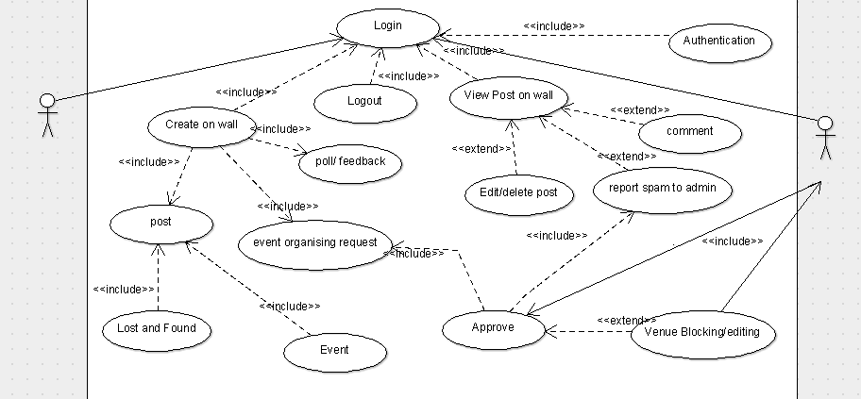

FEEDBACK
4.2.1 Description and Priority
User send the feedback regarding the set of available services provided to him/her. These are sent to the management for evaluation.
Very specific types of service’s feedback can be given by the user who is the receiver of those services. This is sent to the specific department for the checking and action is taken.
4.1.3 Functional Requirements
NO specific functional requirements.

Venue booking
4.3.1 Description and Priority
User applies or request admin for booking venue between particular timings to organize an event. This request is passed through a chain of admins and finally allowed if venue is available. This is of high priority.
4.2.2 Stimulus/Response Sequences
When a request is created by a user, it is sent to the particular chain of admins out of 3 which are Sports, Academics and cultural. These has to be approved by the chain of admins of that category. The final admin of the chain assigns and blocks the venue between the requested timing if available. Else, the request is rejected or provided with suggestions of other available timings.

4.1.3 Functional Requirements
A database needs to be created which keeps track of all these activities and UI which shows the admin what venues of what capacity are free at given timings.
Requirements Id | Function | Description
R1 | Login | This function allows user to login using their credentials.
R2 | Create On wall | This allows user to go to tab where he is allowed to post or create specific things.
R3 | Logout | User logouts from his account after usage.
R4 | View Post | This will help user to see all the posts and events created by other users.
R5 | Authentication | When logging in this will check the user credentials with the DB.
R6 | Poll/Feedback | This is created by the user to get feedback and all user can participate and view this poll.
R7 | Post | This allows user to post on the wall.
R8 | Event organizing Request | In this function a user can request the admin to organize an event in the campus and also ask if certain venue is free at particular time.
R9 | Approve | This allows Admin to approve event organizing requests or disapprove spam posts.
R10 | Comment | This allows the user to comment or claim on event and lost and found posts respectively.
R11 | Lost and Found | This a specific kind of post that can be posted by the user about his lost or found things.
R12 | Event | This is a kind of post where user posts regarding an event being organized in the campus.
R13 | Venue Blocking/Editing | This a feature that allows an admin to block a venue or mark it booked at specific time after he approves an event organizing request, so that other admins knows it. And admin may as well edit the venue/timing and ask the user in case of venue already booked.
R14 | Report spam to Admin | This is when a user can report spam posts to the admin.
R15 | Edit/Delete | This allows user to edit or delete his own posts that have already been posted.

Other Nonfunctional Requirements

Performance Requirements
Product should be very efficient in informing the user regarding all the events and posts in the portal. If it fails there is no need for integrating it with NU Moodle, as many other options such as e-mail and other social media are at use..

Safety Requirements
The posts and events in the portal should be spam free. This can be achieved by checking and approving each and every post either by admin or automate the process.

Security Requirements
There shouldn’t be any security or privacy issues as we only adding a block to a well secured web page and user details are not at all at risk. The spam posts are identified and deleted.

Software Quality Attributes
Efficiency always matters as there is much risk of people not using your portal due to substitute software. We need to make sure we can provide better quality and additional services than our other rivalries. Since this is an Integration to the NU Moodle it shouldn’t have any major bugs or glitches.

Business Rules
Admin will identify the spam posts and event, inform the user who has posted it. All the posts will be deleted from the wall after resolving or certain amount of time, this is taken care by the developers during the development of software. All the feedbacks and complaints should be acknowledged and action must be taken as soon as possible.

Other Requirements
Till now we need permissions for admins of NU Moodle for integrating our software with it. Later we will be needing an effective DB and a DBA to look after all the posts and feedbacks. We also need permissions to gain access to financial DB and library DB for no due form alone. We will be developing the software using HTML and CSS, we may use others as well to make it look more attractive.

